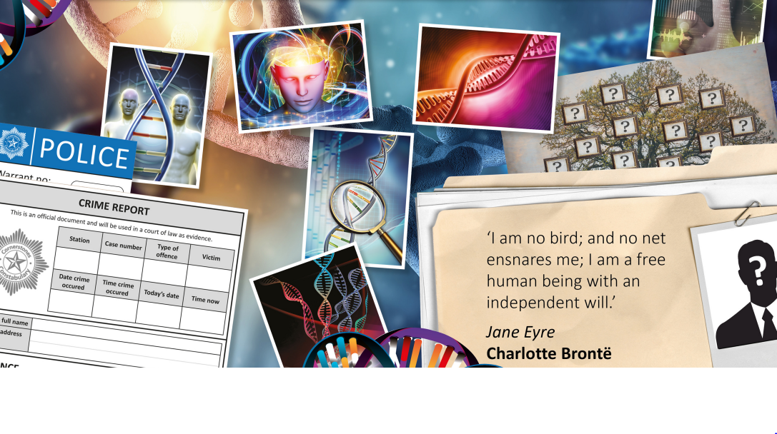

Elder Class – Autumn 1
September 1ST – October 23RD 2026

TOPIC: ID

Half Term Curriculum Overview

PSHE and RE

Computing

English

Mathematics

Science

Music

Explore what a protest song is and why musicians use music to express ideas and opinions.
• Listen to and discuss a range of protest songs.
• Identify how lyrics, melody, rhythm and instrumentation can communicate a message.
- • Explore how music can create different moods and emotions.

- Evolution
- Explore how living things have changed over time.
- Learn about evolution and what it means.
- Discover how fossils provide evidence about living things from the past.
- Explore the work of Charles Darwin and his ideas about evolution.
- Understand how animals and plants adapt to their environments.
- Explore how adaptations can help living things survive and reproduce.

- Place Value
- Read, write and represent numbers up to 10,000,000.
- Understand the place value of each digit in a number.
- Partition numbers in different ways.
- Compare and order numbers up to 10,000,000.
- Use <, > and = to compare numbers.
- Round numbers to different degrees of accuracy.

- - Explore our local identity and our place on Earth.
- - My identity through art
- - My room, my identity
- - The great train robbery
- - Murder Mystery
- - Celebrating our differences
- - My story

- Netball
- Movement skills
- Ball control
- Team Work

PE

- Being me in my world...
- Discuss what makes us
individuals and how we can
work together
- Multifaith: Words of Wisdom
- ?

- Read and explore Wonder.
- Develop our inference, prediction and comprehension skills.
- Explore vocabulary, phrases and character development.
- Develop our grammar, punctuation and sentence structure.
- Write for different audiences and purposes.
- Use paragraphs and ambitious vocabulary effectively.
- Plan, write, edit and improve our work.

History, Geography, Art and D&T

