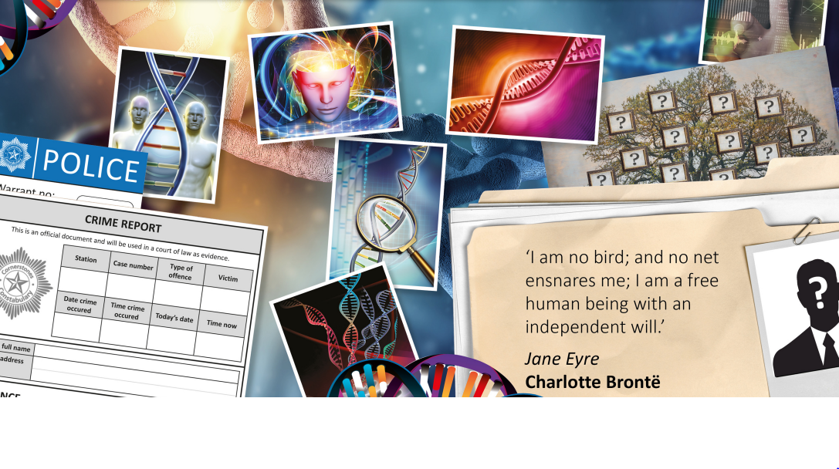

TOPIC: ID

Ash Class – Autumn 1
Sep 2nd – Oct 23rd 2026

Half Term Curriculum Overview

PSHE and RE

PE

Computing

Music

English

Mathematics

Science

- Reading
- apply phonics knowledge to decode words
- Build reading fluency and discuss word meanings
- predict what might happen in a story

- Writing
- use phonics knowledge to spell unfamiliar words
- write simple sentences from memory
- use basic grammar terminology

- Fundamentals
- Ball skills
- Travelling
- balance

History, Geography, Art and D&T

- Being Me
- Getting to know each other
- Making our school a better place
- Faith Stories

- Forces and Magnets
- contact and non-contact forces
- magnetic and non-magnetic materials
- Attraction and repulsion
- Working Scientifically

- Singing

- Indian Classical Music

- Coding
-Design algorithms
-Debug simple problems

- Place Value
- represent numbers
- count on and back
- find one more and one less
- use numberlines
- estimate on a number line

- Addition and Subtraction
- Parts and whole
- Number bonds
- Doubles and near doubles

- Self portraits
- Forms of ID
- How do we use fingerprints
- Plot locations on a map of the local area
- Compare places around the world and find our favourite
- Compare the influence of different historical figures on society
- Design and decorate a item of clothing
- Design and build a model of your ideal space

- ...

