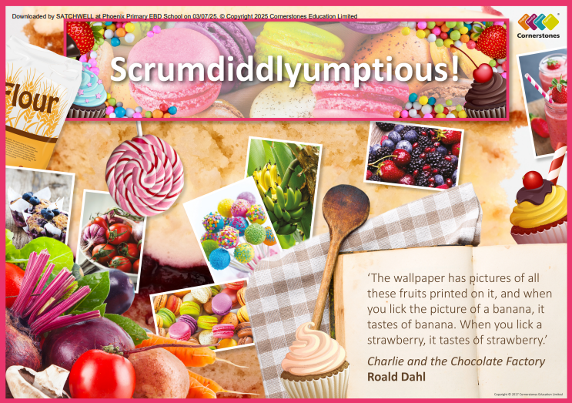

TOPIC: SCRUMDIDDLYUMPTIOUS!

Rainbow Class – Summer 2
1st June – 19th July 2026

Half Term Curriculum Overview

PSHE and RE

PE

Computing

Music

English

Mathematics

Science

- Create a simple instrument
- Create a musical instrument using food and follow a simple rhythm

- Simple instrument and follow
- Create a musical instrument using food and follow a simple rhythm

History, Geography, Art and D&T

- Changing Me
- Puberty and relationships
- Islam
- Akirah

- Changes of materials
- Evaporation
- Reversible changes
- Observe chemical reactions
-Investigate rusting reactions
-Investigate burning reactions
-Investigate chemical reactions – acids and bicarbonate of soda

- Animation
- Introduction to animation using 2Animate
- Enhancing animations

- Time
- Roman numerals to 12
- Tell time to the minute
- Read time on a digital clock – am and pm
- Shape
- 2D and 3D shapes
- Angles
- Statistics
- Pictograms and bar charts

- Athletics
- Stamina and physical fitness
- Preparation for sports day

- Explore climates and biomes of Europe
- Locate Northern and Southern hemisphere
- Bake flapjacks and make smoothies
- Investigate food journeys
- Understand what fair trade is
- Create art in the style of Peter Anton
- Observational drawings
- Making collages
- Create a balanced meal using ingredients from foods grown in a mediterranean biome - tapas
- Investigate the work of James Lind

- Poetry
- Examine different types of poetry and their structures
- Write own nonsense poems and cinquain poems

- Diary Entries
- Write a diary entry from the perspective of visiting a cocoa farm

