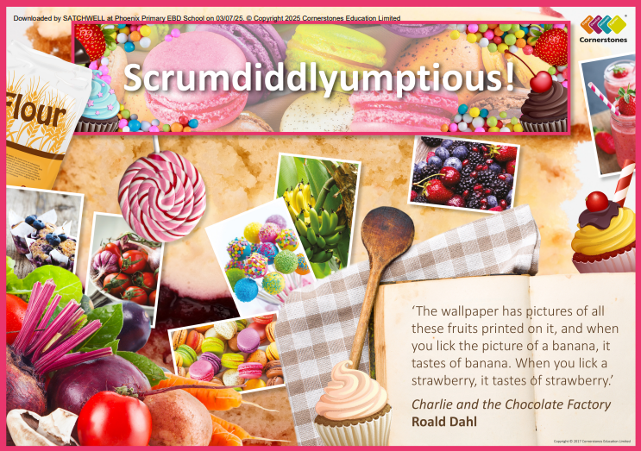

TOPIC: SCRUMDIDDLYUMPTIOUS!

Pine Class – Summer 2
1st June – 17th July 2026

Half Term Curriculum Overview

PSHE and RE

PE

Computing

Music

English

Mathematics

Science

- Children will explore music linked to food, chocolate factories and celebrations.

History, Geography, Art and D&T

- Changing me
- Hinduism

- States of matter
- Compare and group the three states of matter
- Explore how particles behave in solids, liquids and gasses
- Investigate melting points
- Explore freezing and boiling points
- Explore evaporation and condensation
- Understand the water cycle.

- Using external devices
Purple Chip

- Money
- Time
- Shape
- Statistics
- Position and direction

- Athletics

- Different food from around the world
- Compare healthy foods from around the world
- Compare markets from around the world
- Look at the history of chocolate
- Compare kitchens from the past and present
- Explore how school lunches have changed over the years
- Create a food model using clay
- Create bold food artwork
- Create own sweet wrapper

- Write own poems based on food
- Examine different types of poetry and their structure
- Write, perform and recall poems
- Write a set of instructions to make a recipe
- Sequencing and rewriting instructions

