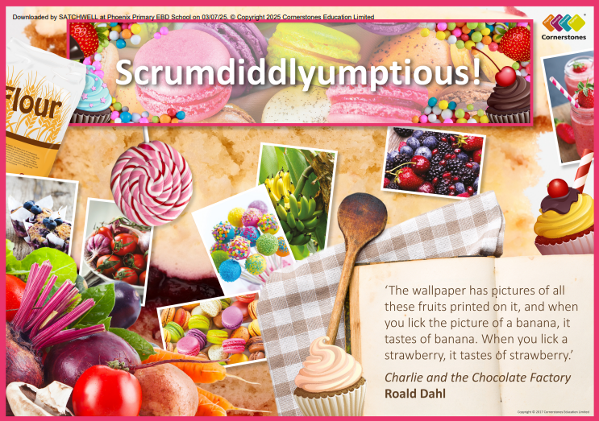

TOPIC: SCRUMDIDDLYUMPTIOUS!

Ash Class – Summer 2
1st June – 19th July 202
Half Term Curriculum Overview

PSHE and RE

PE

Computing

Music

English

Mathematics

Science

- Changing Me
- Puberty and how babies grow
- Islam
- Does going to a mosque give Muslims
a sense of belonging?

- Spreadsheets
- Introduction to spreadsheets using 2Calculate
- Use a spreadsheet for money calculations.

- Singing
- Learn and perform and range of songs

- Swimming
- Teamwork and resilience
- Preparation for sports day

- Poetry
- Examine different types of poetry and their structures
- Write own poems based on food
- Recall and perform different poems.

- Instructions
- Write a set of instructions to make a recipe.
- Sequencing and rewriting instructions.

- Time
- Hours, minutes and seconds
- Telling the time to the hour, half past, quarter past and in 5-minute intervals

- Fractions
- Wholes and parts
- Halves, quarters and thirds
- Time problems

- Animals including Humans
- Organs of the digestive system
- Function of the main digestive organs
- Identifying types of teeth and their functions
- Investigating the effects of food on teeth
- Food webs

History, Geography, Art and D&T

- History
- Celebration foods
- Geography
- Unusual foods from around the world
- Art
- Observational drawings of fruit and vegetables
- Model fruit sculptures
- D&T
- Following recipes
- Healthy eating

