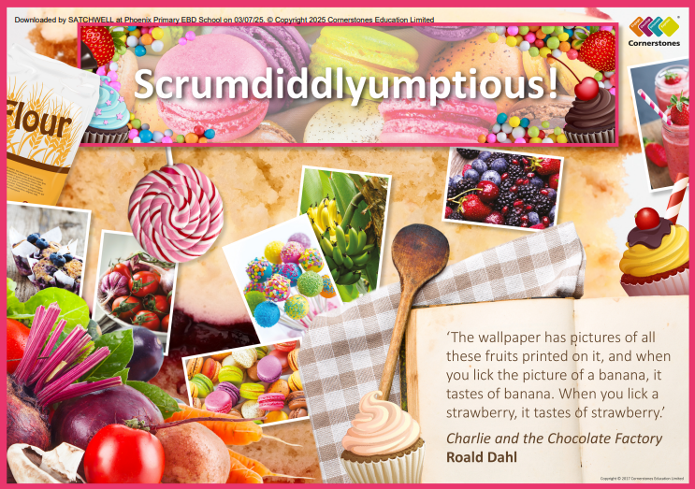

Elder Class – Summer 2
1st June – 17th July 2026

TOPIC: SCRUMDIDDLYUMPTIOUS!

Half Term Curriculum Overview

PSHE and RE

PE

Computing

Music

English

Mathematics

Science

- Shape
- Identify and measure angles
- Regular and irregular shapes
- Symmetry
- Drawing shapes
- Position and direction
- Coordinate problems
- Reflection
- Time
- Intervals of time
- - Converting time

- Animation
- 2D computer animations
- narrative through
animation

- Changes of Materials
- Compare and group everyday materials based on their properties
- Explore how some materials will dissolve to form a solution and how to recover a substance from a solution
- Use knowledge of solids, liquids and gases to decide how mixtures might be separated, including through filtering, sieving and evaporating
- Demonstrate that dissolving, mixing and changes of state are reversible changes

- ?
- ?

- Create a musical instrument using food
- follow a piece of music
- follow a rhythm

- Climates and biomes around the world linked to food production
- Import of food and food miles
- Different types of farming and how geography impacts land use
- Examine how food, availability, production and retail have changed over time
- Combine a variety of ingredients using a range of cooking techniques
- Select appropriate tools to cook a range of dishes
- Use the elements of art to create different representations of food

- ...
- ...

- Poetry
- Write own poems based on food.
- Examine different types of poetry and their structures.
- Write, recall and perform different poems.
- Newspaper Report
- Identify the structure and language
used to write a newspaper report.
- Create a newspaper report to reflect real events or the events of Charlie and the Chocolate Factory.

- Changing Me
- Puberty and relationships
- Christianity
- What is the best way for a Christian to show commitment to God?

History, Geography, Art and D&T
- Athletics
- Stamina and physical fitness
- Team sports and individual events

