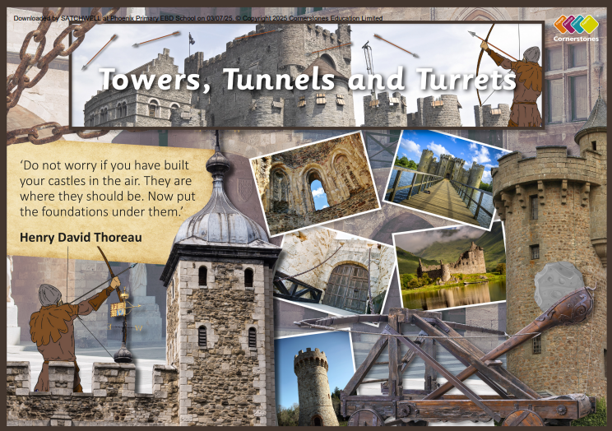

TOPIC: TOWERS, TUNNELS & TURRETS

ASH Class – Summer 1
13th April – 22nd May 2026

Half Term Curriculum Overview

PSHE and RE

PE

Computing

Music

English

Mathematics

Science

- Creating pictures
-using 2Paint A Picture to create work in the style of famous artists

- Relationships
- Roles and responsibilities
- Judaism
The Covenant -How special is the relationship Jews have with God?

Improving our singing technique
History, Geography, Art and D&T

- Forces and Magnets
- contact and non-contact forces
- how objects move on different surfaces
- different types of magnets
- everyday objects that are magnetic
-exploring the uses of everyday magnets

- Length and Height
- measure in centimetres and metres
- compare heights and lengths
- use the four operations with length and height

- Mass, capacity and temperature
- measure in grams and kilograms
- compare mass
- four operations with mass
-measure in millimetres and metres

Building resilience and effective teamwork.

- Research local bridges
- Describe famous towers and tunnels
- Research life in a castle and find out about different roles and titles.
- Design a castle using IT software
- Build a castle using recycled materials
- Explore how to make strong bridges, tunnels and towers.

- Plan and develop a story
- Create a story set in medieval times.
- Focus on vocabulary, character descriptions and story settings.
- Newspaper report
- Identify the structure and language used to write a newspaper report.
- Identify facts to include in a report about a medieval battle

