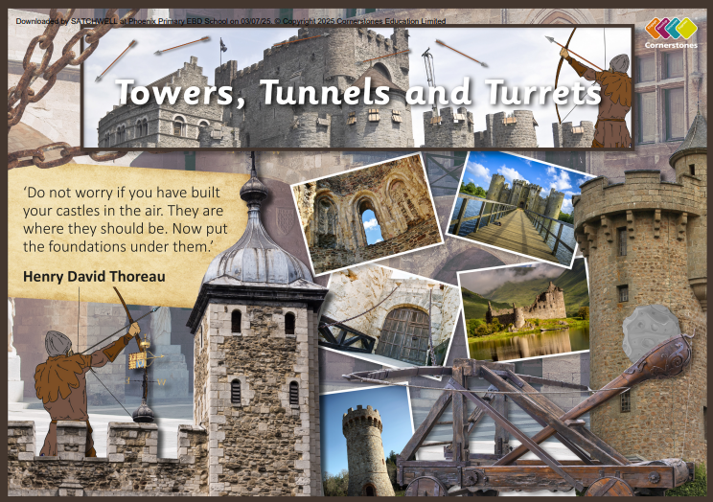

TOPIC: TOWERS, TUNNELS & TURRETS

Pine Class – Summer 1
13th April 2026 –14th May 2026....

Half Term Curriculum Overview

PSHE and RE

PE

Computing

Music

English

Mathematics

Science

History, Geography, Art and D&T

- ...Forces and Magnets
- Explore contact and non-contact forces
- Investigate how things move on different surfaces
- Explore different types of magnets
- Explore everyday objects that are magnetic
- Understand that magnetic forces can act at a distance
- explore the everyday uses for magnets

- ...Relationships
- Judaism
- What is the best way for a Jew to show commitment to God? 4
- Theme – Rites and Passage and Good works

Children are to study different genres of music, looking at composers and how different music makes them feel
- ...Create a story set in medieval times.
- Focus on vocabulary, character descriptions and story settings.
- Write a fact sheet about castles, looking at features and structure. Organise paragraphs with subheadings.
- Newspaper report. Identify the structure and language used to write a newspaper report.
- Diary entries.

- ...
- Word processing
(with Microsoft Word
or Google Docs)

- ...Make a whole with tenths
- Make a whole with hundredths
- Partition decimals
- Flexibly partition decimals
- Compare decimals
- Order decimals
- Round to the nearest whole number
- Halves and quarters as decimals
- Write money using decimals
- Convert between pounds and pence
- Compare amounts of money

Tennis

- ...Human and physical Geography
- Where in the world?
- Castles and Medieval life
- Defend the Castle!
- Jobs in the past
- Design your dream castle
- Build a strong tower competition
- Texture towers
- Light and dark mood

