
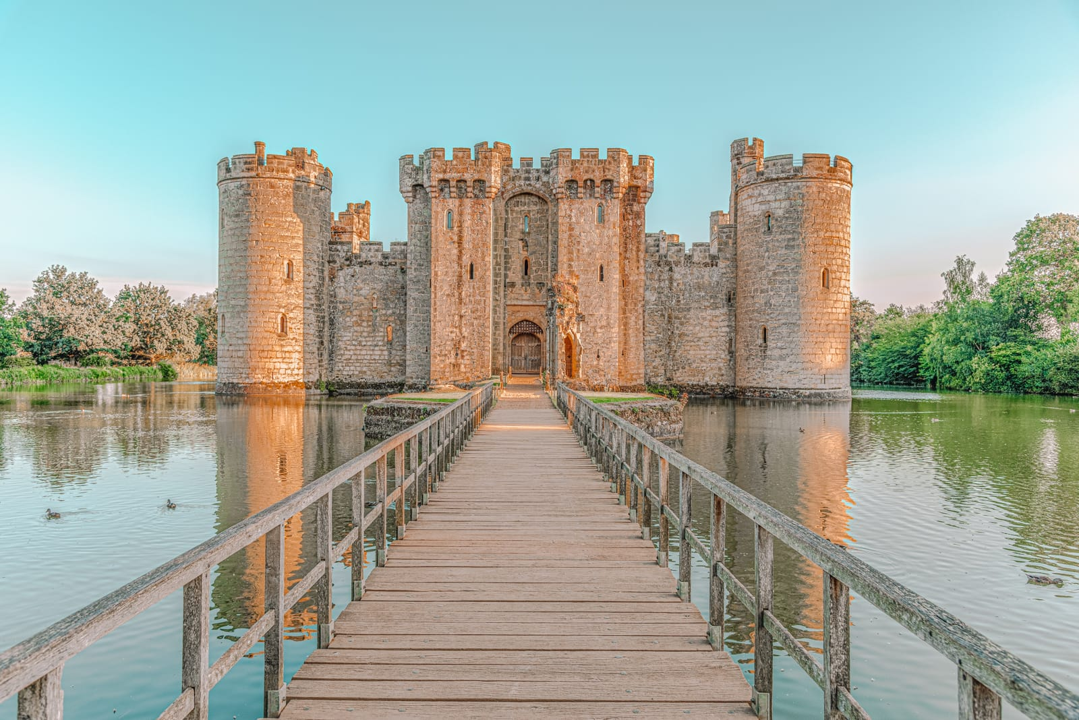
Elder Class – Summer 1
April 13th – May 22nd 2026

Half Term Curriculum Overview

PSHE and RE

PE

Computing

Music

TOPIC: Towers, Tunnels & Turrets

English

Mathematics

History, Geography, Art and D&T

Science

- Word Processing
- Create and edit documents
- Use images within a document
- Search within a document

- Islam
- Relationships
- Mental health, Love and loss, power and control and being safe online
– What is the best way for a Muslim to show commitment to God?

- Follow musical notation
- Follow a musical score.
- Maintain a rhythm
- Play a variety of instruments

- Hockey
- Ball control
- Dribbling and passing
- Team work and tactics

- Investigate how and why castles were build and how they changed over time
- Identify famous landmarks around the world and the UK
- Make a model castle from different materials
- Explore life in medieval England
- Design and create a catapult
- Investigate different types of weapons used in medieval warfare
- Create towers and bridges that meet selected design criteria

- Multiplication and Division
- Multiplication facts
- Multiples and Factors
- Written methods
- Worded problems
- Fractions
- Fraction of an amount
- Multiply a mixed number
- Multiply unit and non-unit fractions

- Plan and develop a story
- Create a story set in medieval times.
- Focus on vocabulary, character description’s and story settings.
- Diary entries
- Write a diary entry from the perspective of a knight away from home and in battle. Evoking the feelings of a witness to a battle and missing family

- Forces
- Explain that unsupported objects fall towards the Earth because of the force of gravity acting between the Earth and the falling object
- Identify the effects of air resistance, water resistance and friction, that act between moving surfaces
- Recognise that some mechanisms including levers, pulleys and gears allow a smaller force to have a greater effect

