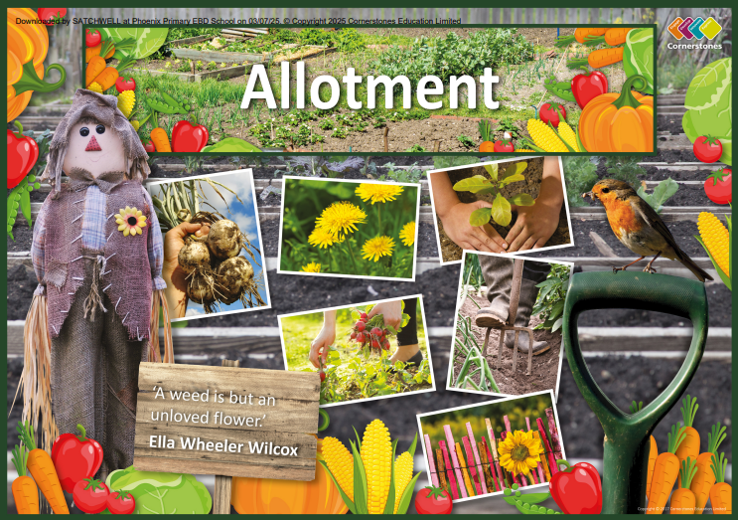

TOPIC: ALLOTMENT

Rainbow Class – Spring 2
23RD February – 27TH March 2026

Half Term Curriculum Overview

PSHE and RE

PE

Computing

Music

English

Mathematics

Science

- Maintain a rhythm
- Follow a musical score

- Spreadsheets
- Converting measurements
- Line graphs
- Planning and budgeting

- Fractions
- understand denominators of fractions
- compare and order fractions
- understand numerators of non-unit fractions
- understand the whole
- Mass and Capacity
- measure mass in grams and kilograms
- measure capacity and volume in millilitres and litres
- add and subtract mass and capacity

- Looking after our environment
- climate change
- how to reduce landfill
- how climate change affects our planet
- explore what is being done to reduce climate change

- Healthy Me
- keeping safe and healthy
- Christianity
- how significant is it that Christians believe God intended Jesus to die

- Spreadsheets
- converting measurements
- line graphs
- planning and budgeting

History, Geography, Art and D&T

- Maintain a rhythm
- follow a musical score

- Swimming

- Use a variety of materials to create a tree habitat
- Recreate art in the style of Andy Goldsworthy
- Make detailed sketches of flowers
- Make soup and fruit kebabs
- Investigate where our fruit and vegetables come from
- Research climates
- Identify human and physical features
- Create a map of the forest area

- ...

- Alter an existing story
- innovate on patterns from a familiar story
- focus on sentence openers

- Instructions
- produce a working leaflet
- recipes

