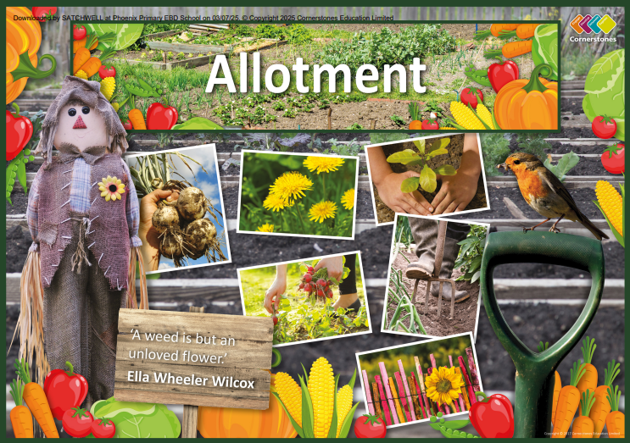

TOPIC: ALLOTMENT

Pine Class – Spring 2
23RD February- 27th March

Half Term Curriculum Overview

PSHE and RE

PE

Computing

Music

English

Mathematics

Science

History, Geography, Art and D&T

- Children are to study different genres of music, looking at composers and how different music makes them feel.

. Healthy me
. Christianity

Understand the life process of a plant
Understand the life cycles of mammals
Compare the life cycles of insects and amphibians
Understand the life cycle of birds and reptiles
Know about the life work of Jane Goodall and David Attenbourough
Research and present the life cycle of a creature

Spread sheets
2 calculate
Measure in kilometres and meters
Equivalent lengths
Perimeter of a grid
Perimeter of a rectangle
Perimeter of rectilinear shapes
Finding missing lengths in rectilinear shapes
Calculate the perimeter of rectilinear shapes
Perimeter of regular polygons
Perimeter of polygons

Swimming
Sports coaches

- Build a dream catcher
- Make cress heads
- Build a bird feeder
- Build a bug house
- Press paintings
- Sculptors
- Natural art
- Sketch books
- Treasure hunt
- Map of the forest
- Map work

- Alter and existing story
- Write and read actual postcards based on their holidays
- Diary entries
- Instructions
- Produce a working leaflet and set of instructions on how to care for our wildlife
- Focus on sentence starters

