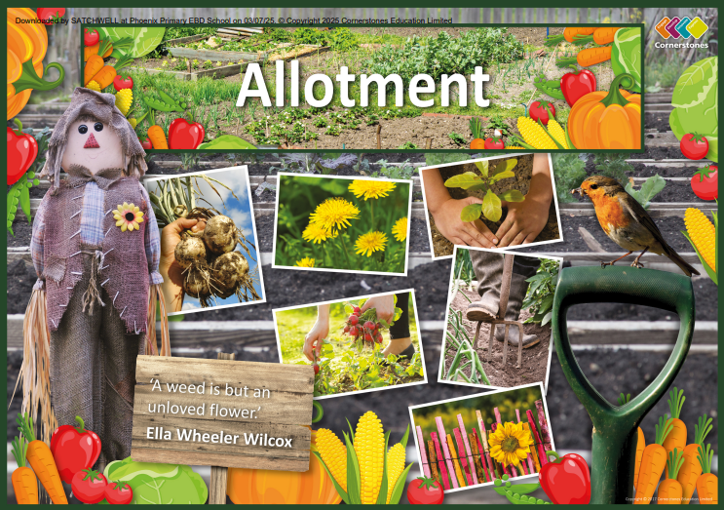

TOPIC: ALLOTMENT

Ash Class – Spring 2
23RD February – 27th March 2026

Half Term Curriculum Overview

PSHE and RE

PE

Computing

Music

English

Mathematics

Science

Singing as a group.
- Christianity
- how important is it to Christians that Jesus came back to life?
- Healthy Me
- Being fit and healthy

History, Geography, Art and D&T

- Investigate local use of allotments
- Use our research of plants to design a suitable allotment area
- Use local maps to evaluate existing land use and plan for growing seasonal fruit and vegetables
- Evaluate existing healthy vegetable-based meals
- Purposefully design and make an appealing product using fresh fruit and vegetables
- Improve our art techniques by exploring a range of materials and styles.

- ...
- ...
- ...
- ...

Plants
- Factors affecting growth
- Functions of different parts of flowering plants
- Transport of water within plants
- The role of flowers
- Pollinators and pollination.

Questioning
- Creating a binary tree
- Using a database to answer questions.
- Multiplication and Division using the 2, 5 and 10 times tables.

- Money – counting, comparing and calculating amounts.

Games to improve teamwork, skills and resilience.

- Write a diary entry from the point of view of a famous explorer. Include the use of the senses to support emotion within the entries.

- Alter an existing story using known story language and patterns. Include dialogue to introduce direct speech.

