
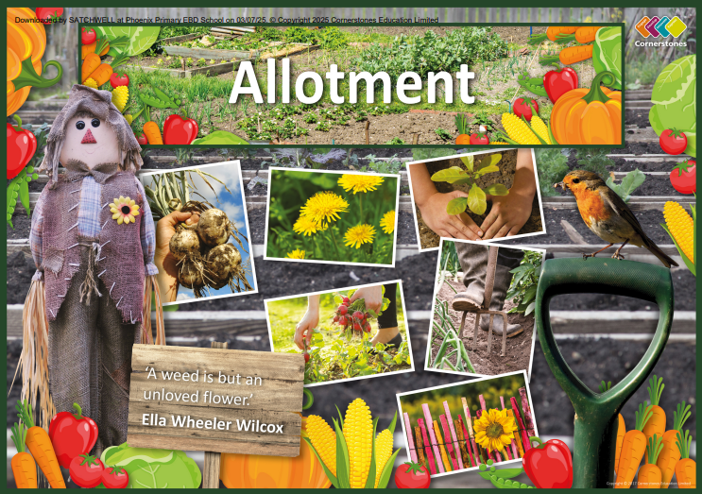
CEDAR Class – Spring 2
23RD – 27TH 2026

TOPIC: ALLOTMENTS

Half Term Curriculum Overview

PSHE and RE

PE

Computing

Music

English

Mathematics

Science

- Hockey
- Ball control
- Dribbing and passing
- Team work and tactics

Target Maths
- Addition and Subtraction
- Written methods
- Mental strategies
- Estimating and checking answers
- Inverse operations
- Worded problems
- Multiplication and Division
- Multiplication facts
- Multiples and Factors
- Written methods
- Worded problems

- Protecting our environment
- Recycling waste
- Climate change
- Human impact upon the environment
- Water cycle
- Conservation
- Greenhouse gases
- Global warming
- Energy consumption

- Healthy Me
- Health and physical wellbeing
- Mental wellbeing
- Is Christianity still a strong religion 2000 years after Jesus was on Earth?
- ?

- Recognise musical notation
- follow a piece of music
- follow a rhythm
- play a variety of
instruments

- Alter an existing story
- Character development
- Story settings
- Plot development
- Descriptive vocabulary
- Story planning

- Instructions
- Imperative verbs
- Time connectives
- Tone and vocabulary

History, Geography, Art and D&T

- 3D Modelling
- Points and coordinates
- Computer modelling

- Design and make planters
- Investigate and create propagators
- Follow a recipe to make a meal
- Food imports and food miles
- Food and the environment
- Sketch maps and mapping tools
- Investigate and replicate the work of different artists
- Make model flowers and foods from a range of materials
- Skecth and label flowers and foods.
- ...

