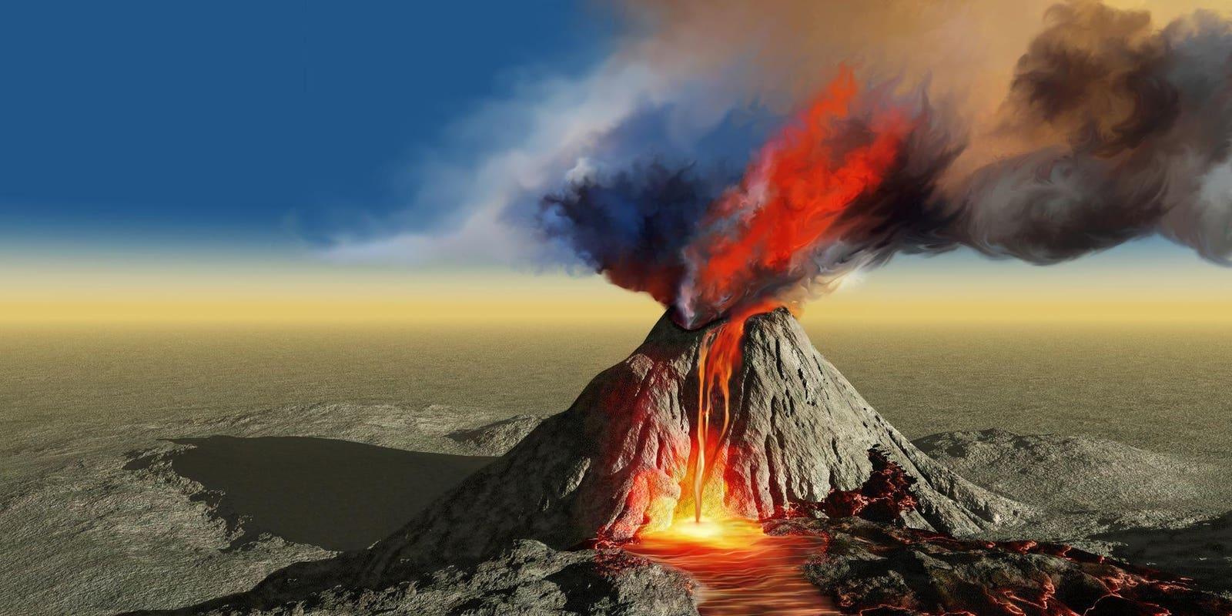

**TOPIC: ROCKS, RELICS AND RUMBLES**

**Rainbow Class** Spring 2

24th February – 11TH April 2025

**Half Term Curriculum Overview**

**PSHE and RE**

**PE**

**Computing**

**Music**

**English**

**Mathematics**

**Science**

* Swimming

- Water Safety

- perfecting different strokes and building resilience

* History
* - Understand the Impact the Roman Empire had on Britain
* Investigate the importance Mount Vesuvius had on Pompeii
* Geography
* - understand the layers of the Earth, the three different types of rocks and fossils
* - Understand how and why Earthquakes happen
* - Art and D.T
* - Use a range of materials to make models volcanoes
* ...
* ...
* ...
* ...
* ...

**History, Geography, Art and D&T**

* Addition and Subtraction

- Add two 4-digit numbers (with exchange)

- subtract two 4-digit numbers (with exchange)

- checking strategies

* Multiplication and Division

- Factor pairs

- multiply and divide by 10 and 100

- Multiply three numbers

- Multiply and divide three-digit number by one digit number

* Create Music

- use Busy Beats to create music

* Healthy Me

- Maintain a healthy body, relationships with food and emergency aid

Christianity-Easter

How significant is it to Christians to believe God intended for Jesus to die

* ...

- ?

* Recognise musical notation
* Follow a piece of music
* identify rhythm
* Living Things and Their Habitats

- Group living things in a variety of ways

- Understand different habitats

- Use classification keys

- Understand the need for adaptation to their environments

* Evolution and Inheritance

- Recognise the changes to living things over time

- Understand what inheritance means

- ?

* Recounts

- Diary entries

- witness account from Pliny the Elder of the volcanic eruption of Mount Vesuvius

Newspaper Reports

-Witness reports

Write a report about a storm that has caused chaos through Walsall