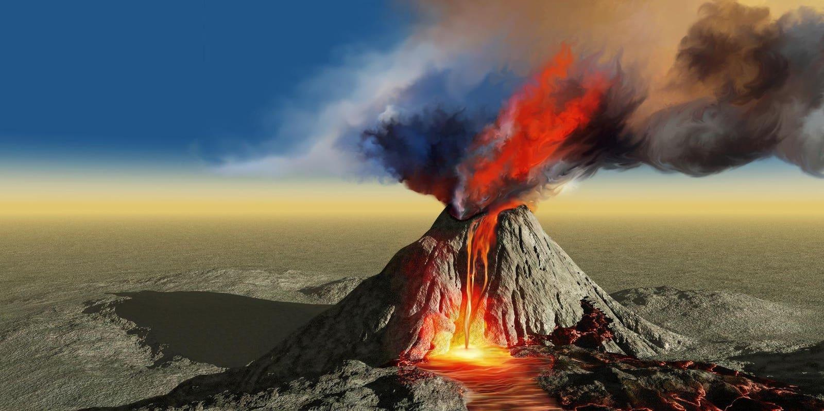

**TOPIC: ROCKS, RELICS AND RUMBLES**

**… Class –**Spring 2

…. …. RD – ……....TH 2025

**Half Term Curriculum Overview**

**PSHE and RE**

**PE**

**Computing**

**Music**

**English**

**Mathematics**

**Science**

* ...Name and describe the types, appearance and properties of rocks.
* ...Name and describe the properties of the Earths four layers
* ...Describe the activity of plate tectonics and how this has changed Earth’s surface over time
* ...Name and locate significant volcanoes
* ...Classify, compare and classify different types of geographical feature
* create a 3D model of a volcano, using different materials to show its layers and structure, and to understand how a volcano erupts.

Online safety

. To know what makes a safe password

. To discover if everything

we read online is true

* ...Healthy me- Christianity

My friends and me, group dynamics, smoking, alcohol, healthy friendships

- -Is forgiveness always possible for Christians? 4

Theme- Easter

Concept - Salvation

* ...

- ?

* ...Compare the effect of different factors on plants

- Describe the functions of different parts of a flowering plant

- Investigate the way in which water is transported within plants

- Explore the part that flowers play in the life cycle of flowering plants

- Understand the pollination process and the way in which seeds are dispersed

-Compare the effect of different factors on plant growth

**History, Geography, Art and D&T**

* .Improvise and compose sequences of sounds and vocals and record them using notes or pictures...
* ...Multiplication and division

- Reasoning and multiplication

- Multiply a 2-digit number by 1 digit

- divide a 2-digit number by 1 digit

* ...Fractions

- Understand the denominator

- Compare and order non-unit and unit fractions

- Equivalent fractions on a number line

* ...Hockey
* To send and receive with some control
* To move safely and with some control
* Understand the role of a defender.
* ...To explore and identify key features of a narrative text

- To use descriptive language and create a setting

-To understand and write a dialogue

* ...Compare and contrast life from the stone age with life today

- Create a short story inspired by the stone age

- To explore and understand the historical context in storytelling