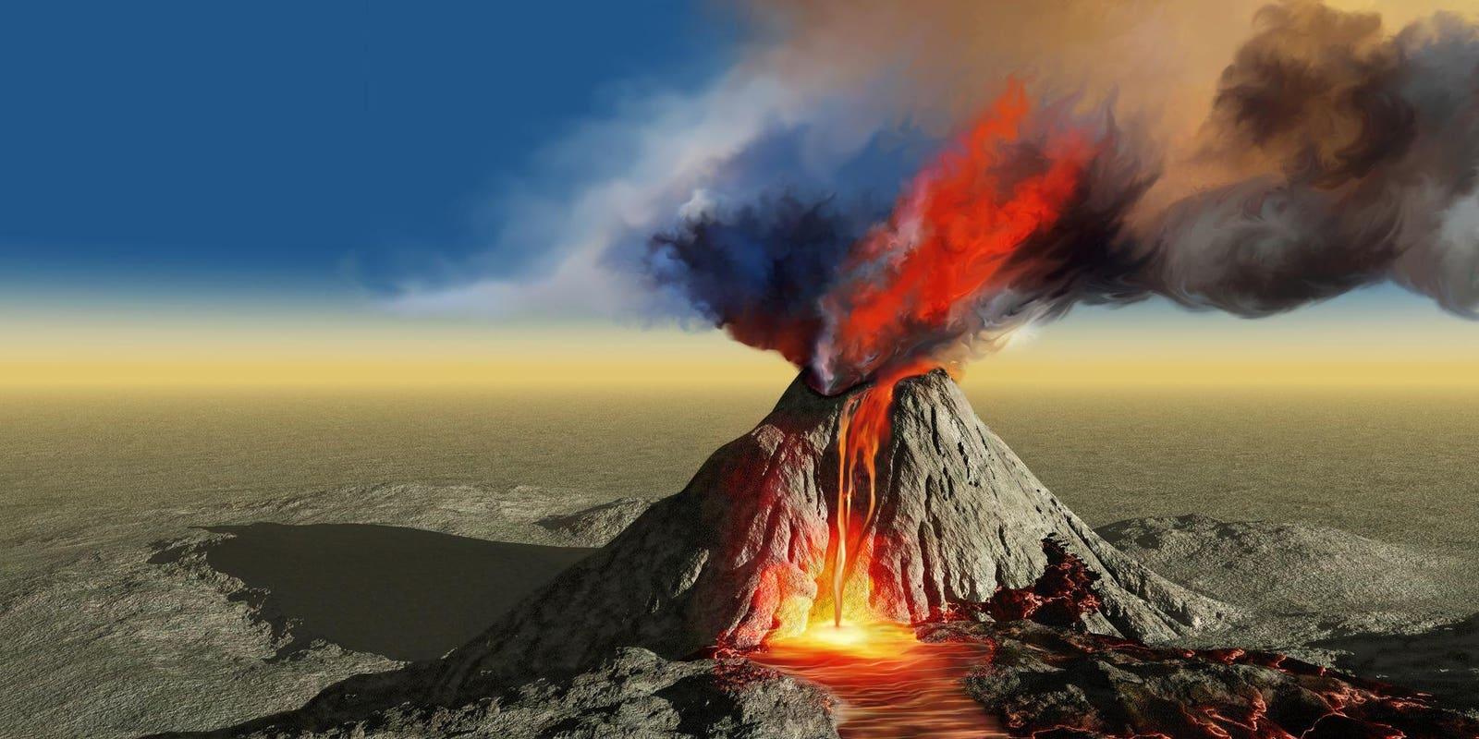

**TOPIC: ROCKS, RELICS AND RUMBLES**

**Elder Class –**Spring 2

24th Feb –11th April 2025

**Half Term Curriculum Overview**

**PSHE and RE**

**Computing**

**Music**

**English**

**Mathematics**

**Science**

Decimals and Percentages:

* Recognise decimals up to 2 decimal places.
* Understand equivalent fractions and decimals.
* Order and compare decimals.
* Understand percentages.
* Understand percentages as fractions and decimals.

Perimeter and area:

* Calculate the perimeter of rectangles. and polygons.
* Estimate and calculate the area of compound shapes.

**PE**

**History, Geography, Art and D&T**

* Recognise musical notation.
* Identify rhythm.
* Follow a piece of music.
* In our RE lessons, we will be exploring the question: ‘How significant is it for Christians to believe God intended Jesus to die.’
* Our PSHE topic is ‘Healthy Me’

Evolution and inheritance:

* Recognise that living things have changed over time and fossils provide information about living things that inhabited the Earth millions of years ago.

Living things and their habitats:

* Describe how things are classified into broad groups according to common characteristics.
* Give reasons for classifying plants.

Databases

* To understand how to

sort, organise and

manipulate data.

* ...

- ?

- ?

* Understand the layers of the Earth, the three different types of rocks and fossils.
* Identify the tectonic plates.
* Understand how volcanoes, tsunamis and earthquakes occur.
* Understand the impact volcanoes, tsunamis and earthquakes can have.
* Investigate the importance Mount Vesuvius had on Pompeii.
* Use a range of materials to make models.
* Investigate the work of Mary Anning.
* ...
* ...
* ...
* ...
* ...
* Volcano poetry. We will explore the use of personification and imagery.
* Newspaper reports: We will complete eyewitness reports of events.
* Diary entries: We will create diaries which sequence events and explore how people would have felt.