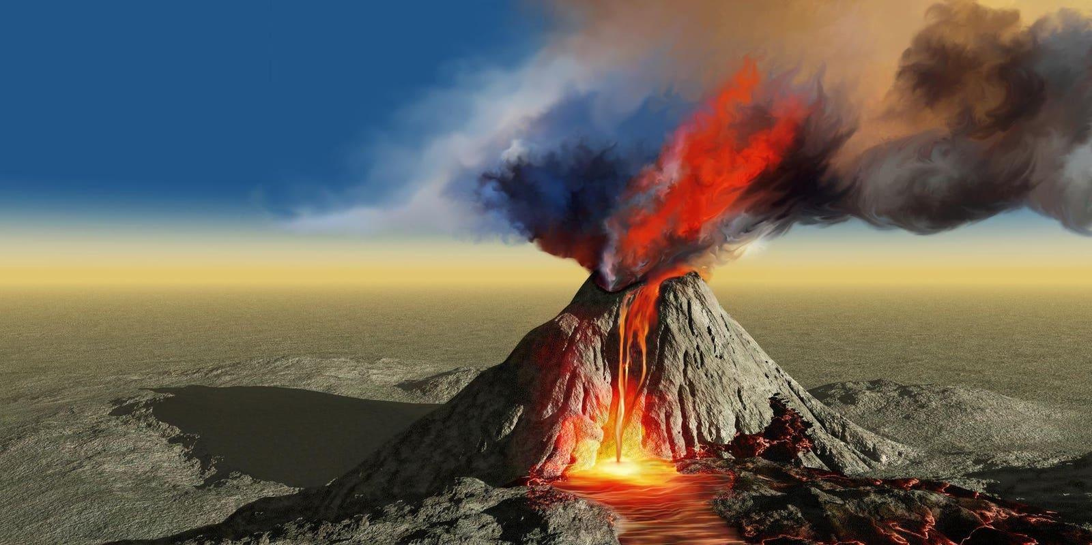

**TOPIC: ROCKS, RELICS AND RUMBLES**

**CEDAR Class –** Spring 2

24TH February – 11th April 2025

**Half Term Curriculum Overview**

**PSHE and RE**

**PE**

**Computing**

**Music**

**English**

**Mathematics**

**Science**

* Healthy Me

- Maintain a healthy body, relationships

with food and emergency aid

* Christianity – Easter

- How significant is it for Christians to

believe God intended Jesus to die?

- ?

* Effective Searching

- Locate information on a

search page

- Identify if a source is true

or reliable

* Recognise musical notation

- follow a piece of music

- follow a rhythm

- play a variety of

instruments

- ?

* Living Thungs and Their Habitats

- Group living things in different ways

- Describe life processes and cycles

- Use classification keys

- Recognise how environmental

changes impact living things

* Evolution and Inheritance

- Recognise how living things change

over time

- Investigate how animals change and

how with reproduction they are not

identical to their parents

- ?

* Length and Perimeter

- Measure distance in different units

- Identify and calculate the perimeter

of different shapes

- Add, subtract and identify

equivalent lengths

* Fractions

- Identify and describe numerators

and denominators

- Compare and order fractions

- Convert mixed and improper fractions

* Learn aboy the layers of the Earth
* Investigate different types of rocks
* Look at soil and fossils
* Use maps to look at longitude and latitude
* Locate volcanoes around the world and look at how they are formed
* Reinforcing structures to withstand earthquakes
* Describe natural disasters and their impact
* Investigate the events surrounding the volcanic eruption at Pompeii and examine evidence to understand life during the time period.
* ...
* ...
* Recounts – Writing the same event in a variety of different ways

Earthquakes and Tsunamis

- Diary Entry

- Letter

- Newspaper Report

* Creative Writing

Plan and write a story based on the

class text of ‘Escape From Pompeii’

- Character development

- Descriptive language

**History, Geography, Art and D&T**

* Hockey

- Ball control

- Receiving and passing

- Team games