Phoenix Primary Academy - Social Distancing and Academy Pupil Capacity Plan
Considering social distancing guidelines along with the suitability and size of each space within our academies we have developed a ratio to safely accommodate pupils whilst still meeting PHE Social distancing guidelines. The following is an example of the number of pupils that can be accommodate in a standard teaching and hall space along with a teacher:
- 55M2 Classroom – 12 Pupils
- 135M2 Hall – 30 Pupils
The ratio adapts dependant on size and suitability of each space as not all of our academies are built to the standard BB103 space regulation. This has been developed using our capacity data, measured plans and knowledge of each site.
We have worked with an architect to draw up plans which outline the maximum safe spacing as detailed above:
55M2 classroom examples meeting social distancing requirements
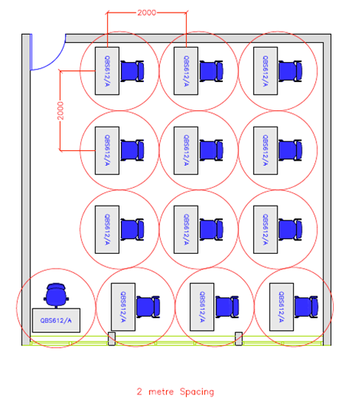

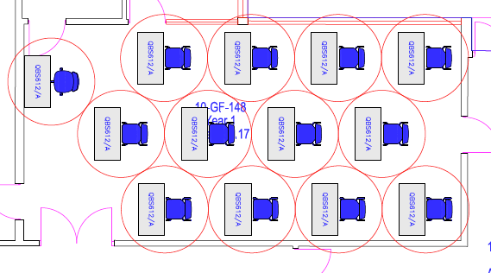
135M2 classroom examples meeting social distancing requirements
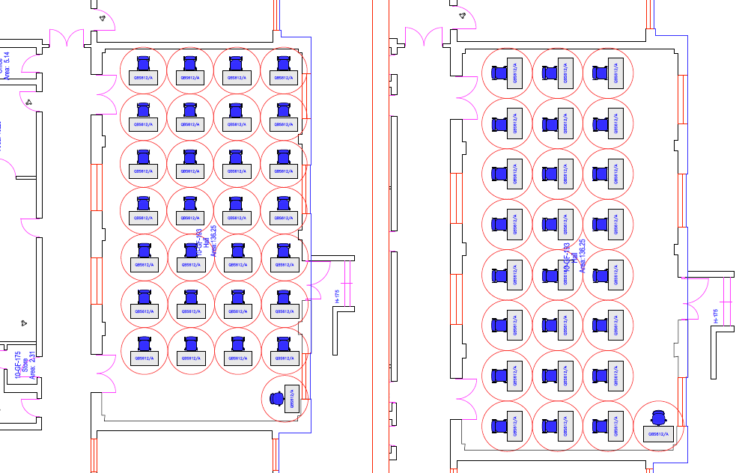

We have then taken this a process a step further and reviewed the available space at Phoenix Primary Academy. This is based on:
- The size of each space within building
- The suitability of each space taking into account fixed furniture and required teachers space
- Location of toilet facillities
- Size of corridor/circulation areas
- Number of pupils expected to return in each year group
- Specific needs of individual pupils
This methodology has identified the following number of pupils can be safely occupy each class space within the academy and still meet social distancing requirements. The following table outline all space within the academy and is numbered in line with the corresponding site plan:

SITE PLAN BELOW

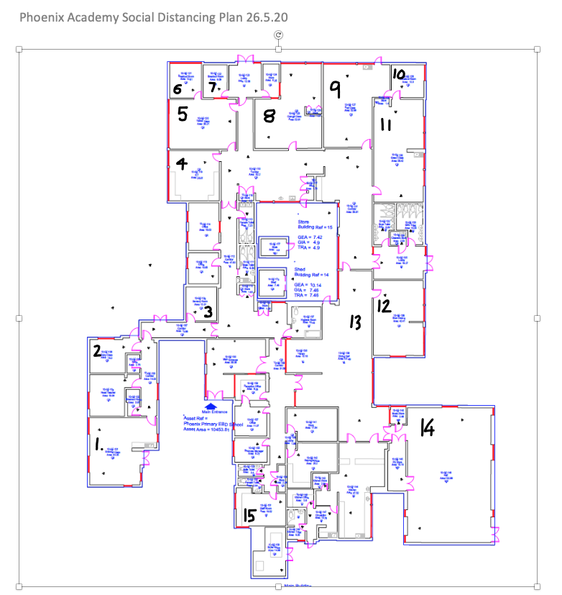
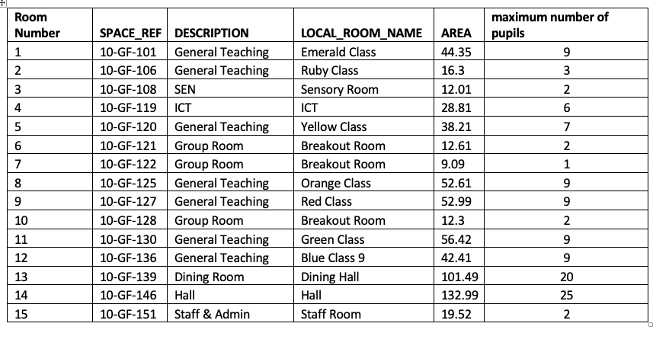

Toilets

