



**Quality First Teaching, Access and Inclusion:**

**A Tiered Approach**

2020-2021

**Contents**

1. Our approach to Pupil Absence and Local/National Lockdown (p2)
2. Remote Education (p3-5)
3. EEF Guide to supporting school planning TEMPLATE – TIERED MODEL (p6)
4. Strategic overview (p7)
5. Coronavirus related absences quick reference guide (p8)

|  |  |  |  |  |  |
| --- | --- | --- | --- | --- | --- |
| **Our approach to Pupil Absence and Local/National Lockdown** | | | | | |
| **Short Absence**  **(Symptoms – Negative Result)** | | **Longer Absence**  **(Positive Result/Quarantine for travel/track and tracing etc.)** | | **Bubble closure/Local Lockdown/Tier 4** | |
| * Paper-based learning materials across the curriculum for the equivalent of a full timetable to be distributed using the academy’s known method e.g. online learning platform, email, post, collection, hand-delivery * Frequency of KIT phone calls from academy staff (class teacher wherever possible) re: safeguarding, well-being, academic progress to correlate with **minimum** frequency detailed below, but will be more often wherever possible. * All completed work to be returned to the academy   1. On swift return following negative test result   2. Via drop-off, post or collection in the event of a longer absence (quarantined) * In the event of a positive test result of a pupil, whilst the above provision would remain, completion of the above would not be expected whilst the child is unwell * In the event of a positive result of a family-member which results in quarantine but the child is well, academies will prepare immediately for longer absence | | * Learning materials (paper-based and/or online depending on the academy’s most effective approach and the context and accessibility of the child(ren) concerned) to be distributed/shared to cover the full curriculum for the equivalent of a full timetable for the period of absence * Wherever possible, child(ren) to be provided with a device to access learning/resources remotely * Content of the learning materials to ensure progression through the curriculum aligned with   1. Teacher’s planned curriculum content   2. Age/stage appropriate, progressive curriculum content from alternative Dfe recommended source e.g. Oak National Academy   Frequency of KIT phone calls from academy staff (class teacher wherever possible) re: safeguarding, well-being, academic progress to correlate with **minimum** frequency detailed below, but will be more often wherever possible. | | * Provision for key worker and critical worker pupils to mirror the progressive, curriculum detailed below but delivered within the academy * Learning materials (paper-based and/or online depending on the academy’s most effective approach and the context and accessibility of the child(ren) concerned) to be distributed/shared to cover the full curriculum for the equivalent of a full timetable for the period of absence * Wherever possible, child(ren) to be provided with a device to access learning/resources remotely * Content of the learning materials to ensure progression through the curriculum aligned with  1. Teacher’s planned curriculum content 2. Age/stage appropriate, progressive curriculum content from alternative Dfe recommended source e.g. Oak National Academy 3. Use of pre-recorded and/or live lessons  * Frequency of KIT phone calls from academy staff (class teacher wherever possible) re: safeguarding, well-being, academic progress to correlate with **minimum** frequency detailed below, but will be more often wherever possible. * Socially distant home visits to take place where vulnerability RAG rating determines these necessary. * Teachers continue to plan for the delivery and assessment of a progressive curriculum using the guidance above | |
| **Minimum Frequency for KIT Phone Calls** | | | | | |
| **EHCP, CP** | **CIN** | | **Early Help, wider vulnerable** | | **All other** |
| Daily | Every 2 days | | Every 3 days | | Weekly |

|  |  |  |
| --- | --- | --- |
| **Remote Education** | | |
| **Remote Education Lead: Elyse Phillips** | | |
| Whilst remote education is offered to all pupils and a timetable of lessons provided, we understand that the nature of some of our learners means that accessing formal lessons and activities can be exceedingly difficult both at home as is it at school. We will work closely with Parents/Carers and pupils to identify what works best for them to create a bespoke and personalised approach to the provision. We ask that Parents/Carers continue to access Class Dojo to upload examples of activities.  We use a combination of the following approaches to teach pupils remotely:   * + recorded teaching   + printed paper packs produced by teachers (e.g. workbooks, worksheets)   + commercially available websites supporting the teaching of specific subjects or areas, including video clips or sequences   + online activities to complete on the Purple Mash learning platform   + Activities shared on Class Dojo to complete and uploaded   Where a pupil is struggling significantly to manage their emotional regulation at home, discussions will be held how best to support the pupil, this may be encouragement for the pupil to return to school if it is safe to do so. | | |
| **Study Time** | | |
| We will aim to teach the same curriculum remotely as we do in school wherever possible and appropriate. However, we may need to make some adaptations in some subjects.  Pupils can expect:  • A timetable of activities  • Daily White Rose lesson (use video and also send home the parent workbook)  • Daily Reading/RWI  • Daily English  • Daily use of Doodle (aim for 30 minutes)  • Weekly Science  • Weekly PSHE  • Topic - supplement activities to fit in with current thematic curriculum  Whilst we recognise the importance of academic subjects, we know that EHCP objectives underpin all what we do here at Phoenix. Even whilst some of our children are being educated at home, they should continue to have access to opportunities to make progress against these objectives. This means that some of our home learning will be based around activities that help to promote certain skills such as:  • Emotional literacy  • Memory and concentration  • Following instructions  • Physical and mental well being  • Social skills  All pupils at Phoenix Academy have a recognised SEMH need which means many may struggle to access formal learning and changes in their routine. We will work closely with parents/carers to support them to help enable their children to access as much learning as possible. We recognise that this can look different on a day-to-day basis and for each child. Regular telephone contact is made at a minimum of three times weekly, one call of which will be from the class teacher to discuss any learning issues specifically. Parents/carers are encouraged to call the Academy if they are struggling to support their child in remote learning. Suggestions and strategies will be discussed to offer the family help, as necessary. This might include for example setting a routine to the learning, or it may be to relax some the routine. Each case is treated individually and just the same as when children are in the Academy, we recognise that “one size does not fit all” and adaptations will and can be made to best support our pupils.  As a guideline, we expect that remote education (including remote teaching and independent work) will take pupils broadly the following number of hours each day: | | |
| **EYFS** | **Key Stage 1** | **Key Stage 2** |
| Up to 3 hours | 3 hours | 4 hours |
| * Wherever possible, pupils should follow the structure of the academy’s suggested timetable which will accompany the remote education resources * Pupils must take regular breaks between periods of study as they would when attending the academy in person | | |

|  |
| --- |
| **Online Remote Education** |
| Wherever possible, pupils will be provided with a device to access learning/resources remotely. Please find our learning platforms below: |
| * Class Dojo – building classroom communities with parents and pupils. * Purple Mash * Doodle - Maths and Reading * White Rose maths |
| **Paper-based Remote Education** |
| Learning materials will be shared to cover the full curriculum for the equivalent of a full timetable for the period of absence. Distribution and return of these resources will be in accordance with the local and national restriction/tier guidance at that time. This process will be communicated clearly by staff each time. |
| **Engagement and Feedback** |
| We use a combination of the following approaches to monitor engagement, gauge pupils’ progress and provide regular feedback:   * A teacher phone calls at least weekly. * Ongoing communication via online platform(s) listed above. * Pre-recorded feedback using videos, demonstration clips or sequences. * Small group live sessions * Work completed on Purple Mash and Doddle will be marked by class teachers or support staff. * Any activities uploaded to Class Dojo will viewed and commented on by staff and successes celebrated * Any progress in skills whilst at home will be monitored by class teachers and used to inform assessment of progress against any target’s children are working on |



**PHOENIX ACADEMY**

**EEF GUIDE TO SUPPORTING SCHOOL PLANNING (2020-21) – TIERED MODEL**

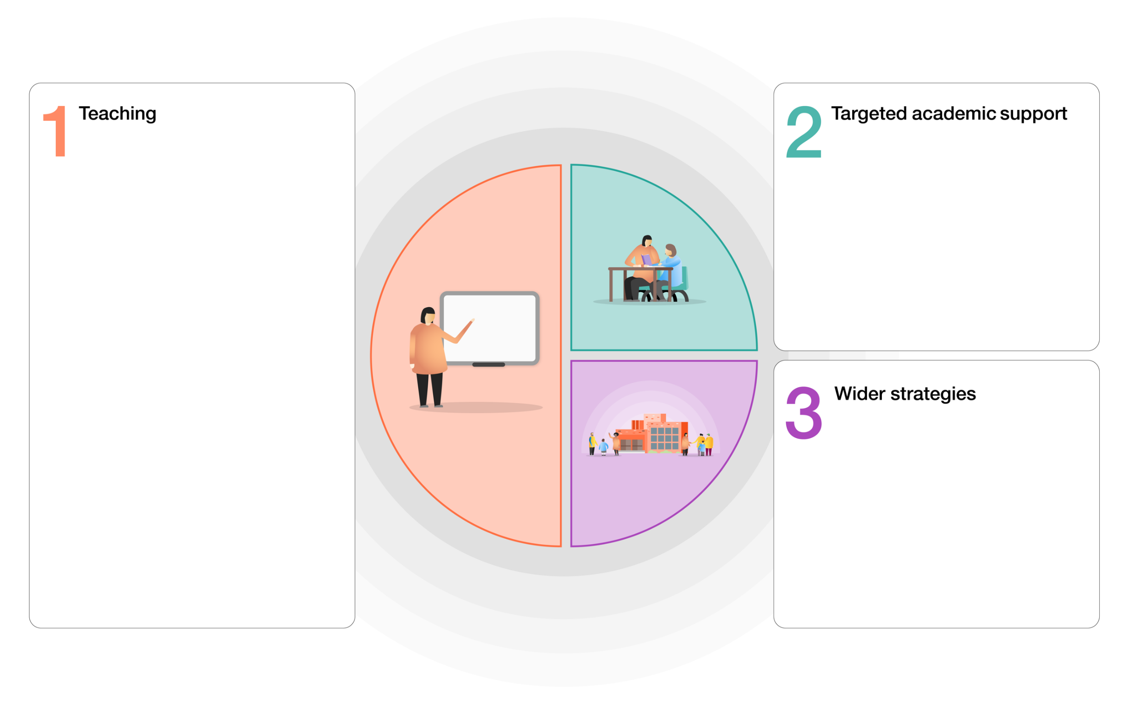

* PE taught by specialist sports coaches
* Extensive outdoor learning provision.
* A rich PHSE programme, including Jigsaw recovery unit
* Safeguarding team to support vulnerable pupils
* Language/ Vocabulary rich environment and curriculum.
* Quality First Teaching supported by evidence based CPD for teachers and support staff.
* A peer-support model to help embed and sustain research-based teaching strategies.
* A broad and engaging curriculum that focuses on building on skills acquisition
* Whole-class reading approach underpinned by clearly defined formative assessment practices.
* Curriculum ‘essentials’ for Reading, Writing and Maths are identified and taught / revisited across wider curriculum subjects.
* Development of a Maths Mastery approach supported by Maths No Problem
* Same-day in-class intervention.
* Phonics and spelling intervention through RWI programme.
* Specific intervention programmes led by both Teachers and Teaching Assistants.
* Baseline assessments to ensure gaps are closed through targeted QFT, skills and knowledge.

|  |  |  |  |  |
| --- | --- | --- | --- | --- |
| **Strategic overview**  This is the overview of how we are addressing the gaps in learning caused during school closures | | | | |
| We have constructed a whole school catch-up plan to ensure pupils are not overwhelmed by the need to regain missed learning and that critically their emotional needs are closely considered in all we do. We want to ensure that pupils have access to quality first teaching , empowering our team of staff by providing them with high quality training, Specific year group ‘gap ‘ filling classroom intervention and small group/individual targeted support; with the child’s health and well-being at the center of all we do.  Purchase of electronic devices to ensure all pupils have online access to learning and intervention to also allow a connection between school and home through still enabling face to face contact.  Interventions will be planned to meet the individual needs of the pupils and be based on need identified through teacher assessment, testing and EHC plan objectives. | | | | |
| **Year group** | **English** | **Maths** | **Wider Curriculum including SEMH intervention** | **Home learning/Blended learning – Using school website, class dojo and home learning packs.** |
| **Years 3**  **to 6** | **Reading**  Daily guided reading using high quality text.  Daily Doodle reading intervention  RWI groups to teach phonics and reading at Individualised levels.  RWI weekly spellings  SALT curriculum | White Rose Maths  Use of the WRM medium term plans to direct teaching and learning.  Use of small steps to break learning down and identify gaps.  Use of prior year group MTPs to address gaps in learning.  Use of WRM assessment tests.  Use of Doodle maths – responsive online maths programme. | Whole school curriculum theme  Differentiation of foundation subject aims and objectives.  Year group science lessons as dictated by the National Curriculum.  Art therapy  Rocket man music intervention  SEMH interventions including:   * PSHE * Emotional literacy * Memory and concentration * Following instructions * Physical and mental well-being * Social skills | Use website/class dojo online to facilitate:  *Purple Mash  *RWI – speed sounds  *White Rose maths  **\***Videos of teacher’s reading and associated Guided Reading activities  *Cornerstones resources for wider curriculum topics |

|  |  |  |  |
| --- | --- | --- | --- |
| **Coronavirus related absences quick reference guide – September 2020** | | | |
| ***What to do if…*** | ***Action needed*** | ***Code*** | ***Return to school when…*** |
| …my child has coronavirus symptoms | **Do not come to school**   * **Contact school daily** * Self-isolate * Get a test * Inform school immediately about test result | Code X | …the test comes back negative. |
| …my child tests positive for coronavirus | * **Do not come to school** * **Contact school daily** * Self-isolate for at least10 days * Inform school immediately about test result | Code I | ...they feel better. They can return to school after 10 days even if they have a cough or loss of smell/taste. These symptoms can last for several weeks once the infection is gone. |
| …somebody in my household has coronavirus symptoms | * **Do not come to school** * **Contact school daily** * Self-isolate * Household member to get a test * Inform school immediately about test result | Code X | …the household member test is negative. |
| …somebody in my household has tested positive for coronavirus | * **Do not come to school** * **Contact school daily** * Self-isolate for 14 days | Code X | …the child has completed 14 days of self-isolation |
| … NHS test and trace have identified my child as a ‘close contact’ of somebody with symptoms or confirmed coronavirus | * **Do not come to school** * **Contact school daily** * Self-isolate for 14 days | Code X | …the child has completed 14 days of self-isolation |
| …we/my child travelled and has to self-isolate a part of a period of quarantine | * **Do not take unauthorised leave in term time** * **Consider quarantine requirements and FCO advice when booking travel** * **Provide information to school as per attendance policy**   **Returning from a destination where quarantine is needed:**   * **Do not come to school** * **Contact school daily** * Self-isolate for 14 days | Code X | …the quarantine period of 14 days has been completed |
| …we have received medical advice that my child must resume shielding. | * **Do not come to school** * **Contact school as required by the pastoral team** * Shield until you are informed that restrictions are lifted and shielding is paused again | Code X | …school inform you that restrictions have been lifted and your child can return to school again. |